

**INTERNAL MEETING MINUTES**

|  |  |
| --- | --- |
| Meeting Purpose | TDWG Sensitive Species Extension Task Group Meeting |
| Time and Date | 23rd July, 2025 from 21:00 AEST |
| Attendees | Cameron Slatyer, Piers Higgs, Tania Laity, Arthur Chapman, Mariko Kageyama, Debora Arlt, Donna Lewis, Alice Hughes, James Wilson, William Morris, John Wieczorek |

**Minutes**

Introductions and Welcome

Cam introduced the session and did a welcome to country.

Data model discussion

Cam and Tania met with John Wieczorek about the new TDWG Darwin Core Data Package model and how that might fit with implementing the draft extension, and the potential ramifications. Tania shared a draft data model with the caveat that it has been reviewed by John who said it could potentially work but more discussion is scheduled in early August to refine it.

The model that tania showed is included here, and is for events only but a similar model could be developed for occurrences.

The idea is to create two new protocols - Sensitivity Reason and Treatments. These will use vocabularies based on the vocabularies that the Task Group is developing. These need to be maintained and the Task Group potentially could have ownership / oversight of these. They need to be publicly available so could be published somewhere like in the ARDC vocabulary service.

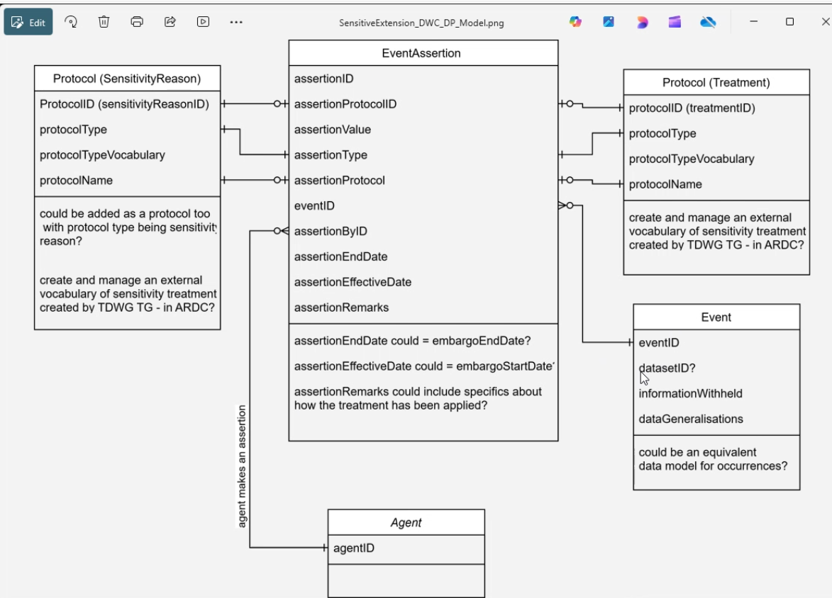

One event can have one or many assertions (these can be based on the protocols developed). This will allow an event (and similarly an occurrence) to have several reasons and treatments associated with it. -

And there is an Agent that makes the assertion. The agent can be either the authority who deems a species sensitive or a data custodian etc.

PH: Not as flat, so can deal with multiple relationships - liked the one to many approach.

WM: This is only for the DWC data package – but it won’t fit back into the DwC star schema?

CS: We do need solutions for both, but it’s easier to start with this and then work out the logic and then backfill it into the standard DwCA package and see what we can do there

AC: Looks pretty good at first look. Left field - should we use RASD instead of sensitivity, or are we still using Sensitivity in the document

CS: we’ve all agreed to go to RASD, but just haven’t updated the language.

AC: Good to do that move early on.

CS: Let’s replace Sensitivity with RASD before we circulate it

**Action: TL will add in RASD to the language and then circulate - then seek comments and thoughts from the Task Group. Any updated versions will be circulated to the group after the discussion with John in early August.**

Final review of the Sensitivity Reasons and Treatments Feedback (v5)

CS: A large number of changes were unsubstantive and have been addressed, so we’ll focus on the main ones that required mor thought / greater changes.

TL: Ran through the main changes to Treatments:

* Moved the strongest treatments (ie Withold category) to the end so that people don’t do that by default.
* Also updated some category level descriptions which were missing
* Added a subcategory - location coordinates are generalised at higher or lower level - can apply up or down the taxonomic tree. This also covers taxonomic splits i.e. if species level are sensitive, then the subspecies are as well

AC: Some typos and spelling - send it to you?

TL: just email it through as well (Donna has most of them covered)

TL: Moving to Reasons and the main changes:

* More substantial changes are around 1.2 and 1.3, and 1.3 as these were brought up by a few people. 1.3 was considered to overlap with habitat protection, so made it more about property and reputational violation of privacy to make it more distinct the habitat sub-category (2.6).
* We have also moved some of the use cases around and changed the wording of some descriptions in an attempt to make them clearer / more distinguishable.
* We also removed many of the general subcategories as they caused some confusing and were too generic.
* Overall we need to update sensitive to RASD where appropriate throughout the document.

CS: Let’s circulate the updated version - Version 6 - and indicate if it’s supported by the Task Group as is, or another review is needed.

JohnW: Not a view in contrary but where we need to go int he future on this - a few people around the sides have mentioned it in the DwC maintenance group - at some point if we create a controlled vocabulary that is part of TDWG and ratified, there’s some specific structure that needs to accompany this extension. I suggest that the Task Group finalise these vocabularies and then work on the technical documentation. One thing that presents a minor challenge - in the controlled vocabs the task group are developing are positive and negative examples which we don’t have a way to specifically include in DWC documentation as it stands. It could potentially be included in the comments or usage notes. So at some point we will need to work on what we need to instantiate it as a standard - DWC maintenance group can help with that.

CS: is it worth changing these into a comments field and rephrasing that as a comments field?

JohnW: We don’t have to do it – in DWC we can allow a value with parenthesis - just put in a parenthetical - we don’t have a spot for negative examples per se but we’ll deal with it.

**Action: TL to recirculate the current v6 treatments and categories to the group - people indicate if you’re happy or require another round of discussion**

Alice: A.5 is taxonomic variation, whereas the rest are geographic- is combining these two forms of removing certainty within one category wise?

CS: We put it there but the rest *are* geographic - is it wise? No. We’ll separate it out so that it’s clear. Agreed that it needs to be moved

WM and JamesW: both asked if it’s necessary / if it was a treatment or reason.:

CS: an example is where a new species has been described out of an existing species, the new species is not in the taxonomy of the database, so the new species will only resolve to the old species or the genus.

TL: Maybe we’re mixing the two here- we don’t have the reason here - so add another Reason to add it in there?

CS: This comes from a precautionary approach - some inconsistency between incoming data and the classes you’re trying to attach to species - it’s something we have to deal with every week

WM: suggested it is an expansion of “taxa is sensitive” because it has some uncertainty around its structure, or something - not quite its own reason

AC: Tricky one - taxonomy makes things tricky - if you have a new species of Eucalypt and make all Eucalypt sensitive it doesn’t make sense…

CS: Two options - reverse matching to the old taxon and making it sensitive or if it matches to genus, make any record directly there sensitive, but not the other ones - no intention of making the whole genus sensitive / restricted. What we do in the ALA is make any record of a species attaching directly to genus sensitive but not everything in the genus sensitive.

WM: Just because it doesn’t map to a formal taxonomy, you restricted the record anyway;

TL: Explained that where you’ve got historical records and they've of the taxon that has been split and one of the subspecies is now considered sensitive. There is no way of telling which subspecies the record of the species should be attributed to unless they are very clearly geographically split. If both subspecies occur together or close together geographically, then it's going to be harder to say that these particular records of the species are this subspecies, and they should be generalised. So what we're saying is that to apply the precautionary principle we sensitize all of them. The same goes new species as well. So what Cam was saying, if there's species that are not described and there's no published name for them it's hard to tell from the records which could be attributed to that new taxon and you could be exposing sensitive records. .

JamesW:OK.

CS: So the question is, thinking about it further, do we need to keep it? Is this a methodological issue.

WM: Yeah.

TL: I think it's a reason because we then apply the same treatments to those higher taxa.

JamesW: agreed and I think it's reason 2.5.

TL: we didn’t have those use cases in there before, we might need to maybe group it into 2.5 and review it.

CS: Let’s flag that in the next version and test it.

**Action: TL and CS to review the matching to higher taxonomy treatment to either formulate it into a new reason or add the use cases to 2.5. Recirculate this with V6 for comment to the group.**

And an interesting issue from James regarding Generalising Coordinates

JamesW: Let me lower your expectations and let’s talk generalisation of coordinates with reducing decimal places and standardising grids. I’m chasing a standard method for doing this, and I don’t think this document is the place for this - think it might be more appropriate to update Arthur’s document. I’m pushing for a standard method within the department/state and nation or potentially internationally.

A bit of semantic quibbling between rounding and truncating… and what happens when you truncate in negative numbers.

(James’ email for context)

* Generalisation B.1 and B2: I see these two as the same. If you are reducing the decimal places of a record, you are actually representing the corner of a polygon and this should be communicated in metadata. I would like to clarify ‘reducing the number of decimal places’ for us in the southern hemisphere and recommend ‘rounding down the number of decimal places’. If people take a truncation approach then in the northern hemisphere this will represent the south-west corner of a polygon, and in the southern hemisphere this will represent the north-west corner of a polygon (because all of our latitudes are negative). The GIS tools to create a polygon all require the south-west corner as a starting point to create a grid square, so I recommend that the standard is to round down and describe a point that represents the south-west corner of a square. This is the text I have put into our (draft) generalisation methodology for the department:
  + When spatial locations are generalised, the accepted method is to ‘round down’ the coordinates and represent them as the south-west corner of a square of a described size. For example, a point at -22.216046, 147.298698 may be described either as:
    - A square polygon with dimensions of 0.01 x 0.01 decimal degrees with the south-west corner at -22.22, 147.29, or
    - A point at -22.22, 147.29 with metadata explaining that the point represents the south-west corner of a square polygon of 0.01 x 0.01 decimal degrees

When you truncate you’re representing the point as a grid.

In the grid square it asks for the south-west corner, but when you do this truncating in the southern hemisphere you get the north-west corner.

Rounding down can take you in different directions

From Arthur’s document:

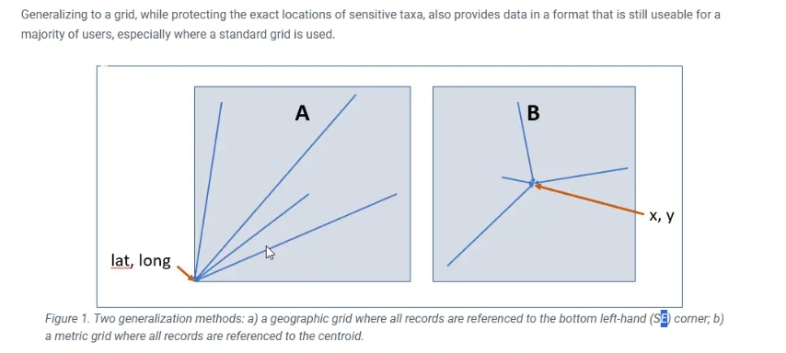

James’ favourite method is Arthur’s “A”

Reducing coordinates moves it into a grid and could be followed that way. But remember when you truncate in the southern hemisphere then it is the northwest corner

AC: Agree, may need to alter the georeferencing best practices section

JohnW: I wouldn’t make it so complicated - S-W corner is a bit weird when positive and negative - so with the negatives it gets weird. Let them truncate, reduce or round as they do - and if you want to do something you can re-instate it in the use of the data, don’t put the burden on the provider. They need to document what was done, so users can reconstitute the grid easily

JamesW: I want stuff to be easy to get into my system as an aggregator

JohnW: Let the data provider truncate, it will be a number, depending on the quadrant the point will end up with some corner of a grid - you know what they did (you need to know).

JamesW: That’s my problem, you don’t get told everything.

John: If you know nothing about what they did you are in the center of four possible grid cells – see diagram:

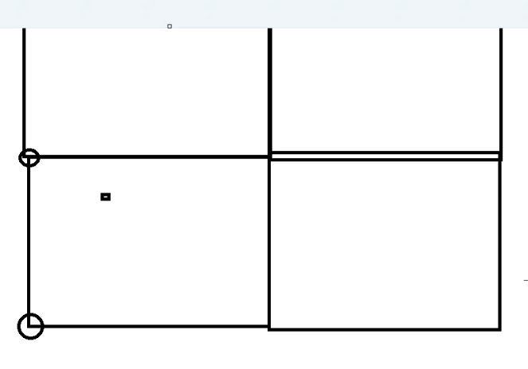

JohnW: Not put burden on the provider, just tell us what has been done.

TL: The task group’s work is aiming to make it clearer on the data what has happened to it. As a group we need to come up with some example text where we replace attributes. Totally agree with what we recommend people do and document treatments applied to the data.

CS: Use the same phrasing (ie shorten rather than generalising / rounding / truncating) in the document moving forward.

JohnW: Different way of talking about a georeferenced protocol - useful on both slides - in the georeferencing and in the RASD stuff and georeferencing best practices - good way to propagate the protocol everywhere - would be good to link to the georeferencing protocol as well.

CS: Is it worth expanding in the georeferencing document?

AC: Maybe, I’ll change it after we settle here a bit more. Centroids are terrible in many ways, there are too many of them for use

JamesW: Agree, it’s not the place, so recording what you’ve done is the most important thing. Please just reduce by rounding, truncating, etc - needs to be done.

AC: Also note Alice’s chat (below)

Alice from TEAMS Chat

we can note a recommended guidance, and then "other options"

I read the uncertainty as some might be vulnerable to trade etc- but the geographic obscuring would work in that case

CS: Closed the meeting

Meeting Closed: end time